Proposal of National Medical Web
A project that help user to go to doctors everywhere in China

Sam Yan
Computer Science Department
Wenzhou-Kean University
Wenzhou, China
yanjiangyue756@wku.edu.cn

Abstract—This project proposed a basic structure of building a national wide medical record for Chinese citizens. It states the background of this structure, the design of database related to this project and the design of program structures related to this proposal. The structure is being implemented and tested through the development procedures and proved to be applicable for doctors and general citizen users.
Keywords-Proposal, Medical Records, Project Design, Policies

Introduction AND BACKGROUND

In China, until this report has been written, there is still no national medical data system which can be used to provide information of patients national wide. This may lead to problems such as over-checking and over-treatment, which not only waste medical resources, but also introduce harm to patents’ health.
In some extreme cases, this problem tends to be vital especially when patients lose their self-consciousness or have limited ability to explain their symptoms due to various kinds of reasons.
This project tends to provide a very basic model of national health information available for citizens and doctors vary in different hospitals located in different cities. After the implementation of this project, the patient can easily get therapy services simply with his or her “Citizen Identity Card”, a card that every Chinese has, in an accurate and traceable manner.

Literature review
This is a project which involves system design, database design, web application design and network security. As knowledge about database design, hidden forms, linking to database and user authentication is already presented in the paper of my first project paper, this paper only presents two new technology learned and used.

- About Multiple Query:
Multiple query in database means to fetch information separated in different data fields. Database design obeys the rule that data redundancy should be minimized, thus a usual mechanism is to separate attributes (columns) into different data fields (known as entities, or tables also). But when information related to different data fields needs to be fetched, different data fields should be linked together by database operations such as join, natural join or others, leading to multiple levels of querying sentences.
For example, in the system hospitalID is an attribute of entity doctor, indicating the ID of the hospital that the certain doctor is currently working at. Another entity, hospital, includes detailed information including hospitalID, hospital name and the location of the hospital. The goal of this design is to reduce data redundancy, because storing an ID leads to take up less spaces compared to store the string of a hospital’s full name. However, when the full-name of the hospital the doctor is working at is needed, selection operation between the two data fields needs to be performed, leading to multiple level of querying sentences.



In this query, the second layer of query “SELECT hospital ID from doctor WHERE username = ‘doctor_user’” gets the ID of that hospital the doctor is looking at. The result is returned as the conditional part of the first layer of query, namely, “WHERE hospitalID = ‘ID’ “. Then all the information of the corresponding hospital is available from “SELECT * FROM hospitals”. Letter “H” and “D” in the query are used to eliminate ambiguous of the same attribute in different tables.

Another example, using natural join logic between two data fields, is implemented when the location of the hospital needs to be checked.

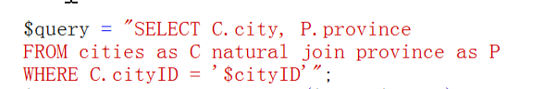

Again, to minimize data redundancy, information about the city the hospital is located is separated from the information about the province the hospital is located. Natural join is performed to get which city and which province the hospital is located.

- About the use of cookie:

In this project, together with forms and hidden forms, cookie is used as a third method to pass data through background and foreground.
For example, when citizen is trying to input invalid information during registration, a cookie is made to indicate the wrong information he or she is entering and the information goes back to the original form he or she submitted before.
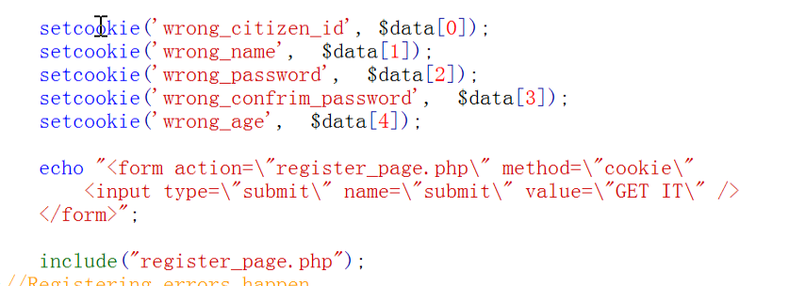

Then the receiver side is able to get the information of the cookie containing invalid data and present it to users.

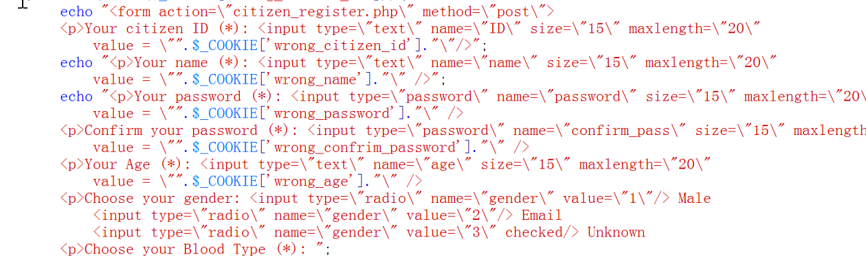

System design

Design of the database

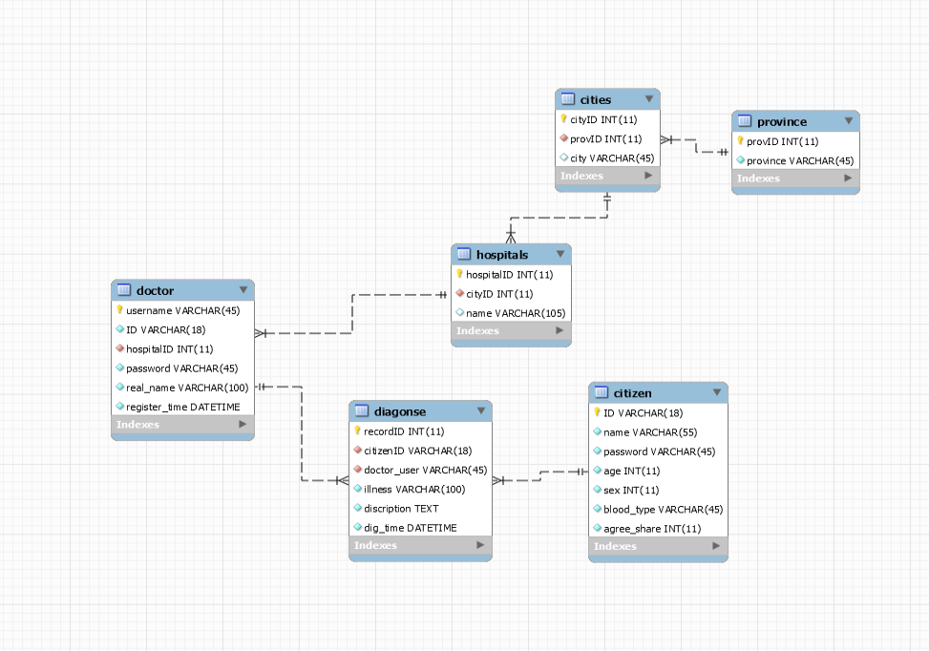

As the detailed steps are already introduced in the first paper of submition, this paper only focus on the explanation of how foreign key constrains and entity relationships are added to the database system.
For example, there are many cities in one province, so the relationship between cities and provinces is many-to-one. Thus foreign key constrain is added on the attribute of cities, it is referenced to province entity to ensure the province the city belongs to exists. Similar design is applicable of the relationships between hospitals and cities, diagnoses and citizens. (One city has multiple hospitals, one citizen may has many diagnose reports)
Many-to-many relationship also exists in this project. For example, one doctor may serves to many citizens and one citizens may went to different doctors in different hospitals to check. When this case happens, foreign key constrains are added to the relationship between those two entities, namely, both username of the doctor (Primary key for doctor entity) and ID of citizen (Primary key for citizen) is recorded in the diagnose table (Doctors diagnose citizens, citizens go to various doctors for diagnose), referencing to the corresponding primary key in according entities.

Design of program structures

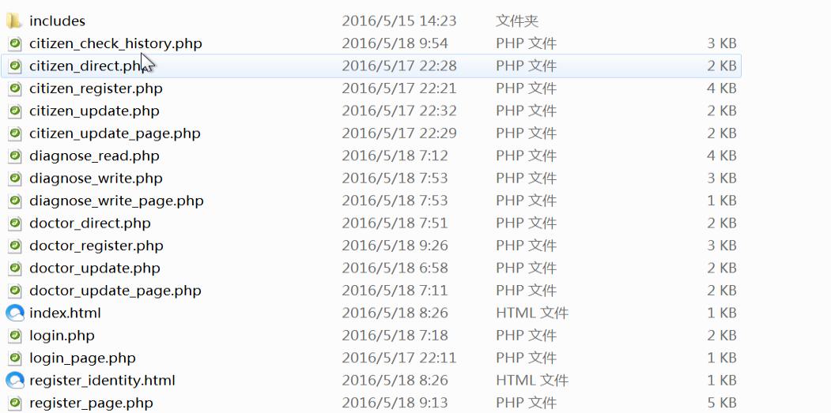

The programs are designed two meet the structure of the database and the needs of users. Users are divided mainly into two categories, doctors and citizens.
First, all the users have to log in into the system before they are able to do any operation for the sake of system security and the protection of users’ information. The “index.html” page will ask their identity and lead them to “login_page.php”, where users enter different information according to their different identities. “login.php” will check their validity and lead different user to different pages. Citizens are lead to “citizen_direct.php” while doctors are lead to “doctor_direct.php”. The two direction pages contains all the functions this type of user needed.
As for citizens, they are provided with 2 functions. One function is to update their information, another is to view their own health history in different hospitals. “citizen_update_page.php” provide interfaces for citizens to update their information while “citizen_update.php” does the real update operation. “citizen_check_history.php” fetches ones history from database and shows it for a certain citizen. Thorough this design, both the user requirements and the privacy issues are considered, that is, a citizen is only able to see his or her own health records and his or her personal information, other citizens can not.
As for doctors, they can also update their information, the programs for doctors to update their information is similar as the structure of citizens. Second, they can check a citizen’s history by entering the citizen’s ID number in “diagnose_read.php”. The doctor can also go to “diagnose_write.php” to record a new case when a patient comes for medical service.

Design of User Interfaces

The point of this course is more for us to learn to use the background of web programming, so most of the time is spent on the design of implementation of the database and the program structure. The interface is similar like the case in the first project. However, improving the quality of interfaces to make them more enjoyable is one way of future work after this course.

system tests
As also stated in the first project, the goal of system test is to ensure that “The system meets user requirements” rather than “The system has no bugs on the main paths that users may go through”. According to this goal, the project is implemented, fully tested and almost achieve all the functions needed from the perspective of this proposal.

Testing of User Login Interfaces and Programs:

In the register.php, Type in SamYjy, choose identity as a professor, and type in password “wku12345”, real name “Sam Yan” and corresponding email accounts and certain user id. The system generate information shown above in the database.

Testing Example of Doctor Interfaces:
Start from “index.html”, first the role of a doctor is tested. The indexing page has no problem leading a doctor user to login page, requiring username and password of a doctor.

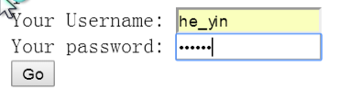



After entering correct username and password, click “go” and “go to my page”, the doctor is able to see the functions provided for him or her. And her basic information.

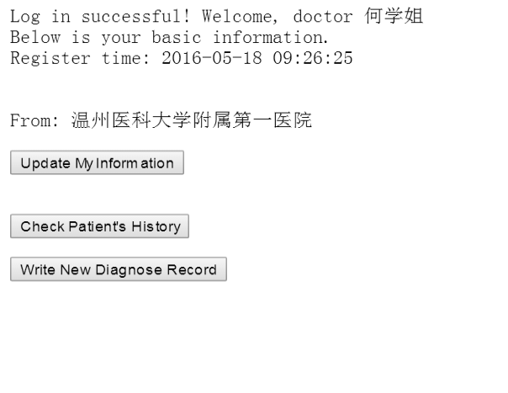

Next, the doctor user can click the updating button if his or her information changed. In the testing case it is suggested that the name of user is changed to “何秋香” and the hospital is changed to Ningbo No.1 Hospital instead of Wenzhou No.1 Hospital, the filling of columns is shown as:

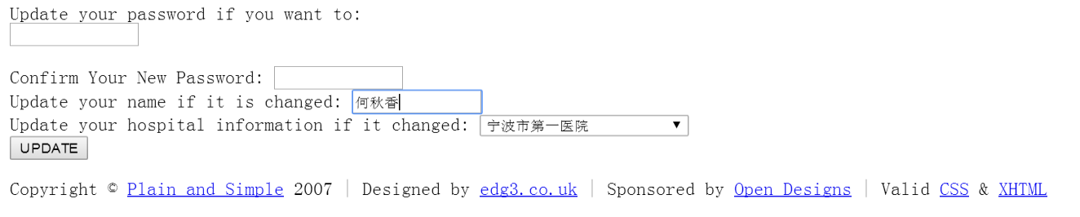

The page will show the success of information update and the database will record the new information.

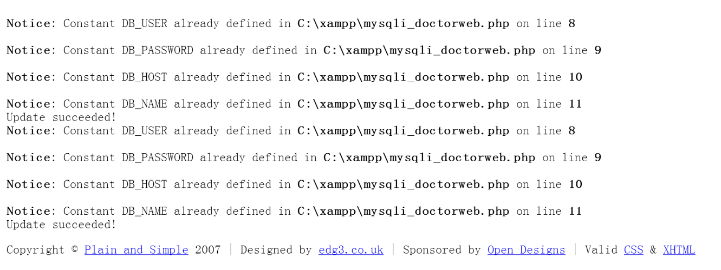



Following similar procedures, functions such as doctors add patient health records, doctors read patients’ histories, citizens update their data, citizens check their health history, citizen/doctors register are tested one after another. Testing suggests that all those parts are available to use. For further testing and details, the entire program code is also submitted in Blackboard for downloading.

discussions and conclusions
This project proposed and implemented a proposal of a possible structure that linking Chinese citizens’ health data across the entire country. It goes through database design, program structure design and implementation and finally the project test. The testing results suggests that the system is available for users of doctors and citizens to use to check and record their health records in different hospitals located in different places.
According to an online survey related to this project proposed at the link:
http://www.sojump.com/jq/8313770.aspx
by the author, it is found out that almost all the doctors think that in emergency cases patients’ lives tend to be more important than their private data. What’s more, the research found out that 80% doctors or medical students require such a national wide. 80% of the doctors or medical students think it is vital for them to check the patients’ historical records from different hospitals in order to come up with a better treatment for various problems the patient may have.
According to Dr.Winoto’s evaluation, the system itself also may have a wild range of usage. Medical industries may use the data from the project to improve the effects of the medicines. Doctors may compare different methods aiming at curing a certain disease to conclude better therapies. Data mining works showing the health conditions related to Chinese citizens may also be performed based on this system.

problems and future works
- As the time is limited and the key points for this subject is not front design, although the back-end of the proposed structure is nearly perfect, there are really works need to be done to improve the interfaces to make them more enjoyable and easier to use.
- According to the design and implementation, once the doctor knows the citizen ID, he or she may able to check anyone’s health record even when this doctor does not really need the information. Later works have to be done to ensure that doctors are only able to check the information of citizens that really come to him or her, improving the safety of citizens’ privacy.
- This application is developed under standalone condition with php and MySQL for showing the basic structure of the proposal, it may works for the condition that the records are under “million” level. But in real application, the population in China is already much more than this quantity of data. How to implement the design for larger data needs to be considered.
- Now it is still a design. As for how to persuade medical schools, hospitals and clinics to really use it is also one think needs to be taken into consideration as different hospitals have their different ways of recording health records.
- As one expert proposed in the online research proposed before, patients’ situation may be changing suddenly. In this case, the history of his or her health records tend to lose value. If the system can predict what exactly the sudden situation may happen to the patient, it will then be much more useful, which requires some works on data mining.
- As the growing of this system, database security, data integrity and privacy policies are all issues need to be taken into consideration when the actual program grows larger.

- Due to time and ability limitation, there might be problems that are not discovered till the moment that the paper work is finished.

Acknowledgment
At the moment that the project is finished, I would like to express my most honest appreciate towards my instructor Dr.Winoto, who really leads me into the door into web programming. It is also him who introduced us with his previous experiences in South Korea that makes me think it is valuable to develop such a system.

References
- Ben Shneiderman and Catherine Plaisant, Designing the User Interface, Strategies For Effective Human-Computer Interaction Fifth Edition, in 2013, Pearson
- Erich Gamma, Richard Halm, Ralph Johnson and John Vlissides, Design Patterns, Elements of Reusable Object-Oriented Software, in 1994, China Machinery Press
- IEEE Computer Society, Computer Science Curricula 2013 Curricula Guidelines for Undergraduate Degrees in Computer Science, in 20th December, 2013, IEEE.
- J. Li, X. Song, T. Yang, Y. Chen, Y. Gong, X. Yin and Z. Lu, A Systematic Review of Antibiotic Prescription Associated With Upper Respiratory Tract Infections in China, Medicine (Baltimore), vol 95, p.g.19, e3587, May 2016.
- Larry Ullman, PHP and MySQL for Dynamic Web Sites, 4th Edition, in 2012, Peachpit Press
- Mike O’Docherty, Object-Oriented Analysis & Design, Understanding System Development with UML 2.0, in 2005, John Wiley & Sons, Ltd
- Ou Liqi and He Jinchi, Talking about Software Testing in a Funny Approach, in 2014, Publishing House of Electronics Industry
- Wangshan, Sa Shixuan, Database System Concept, 5th Edition, National Computer Science Required Coursebook for “the twelves five-year plan” of China, in 2014, Higher Education Press
- William Stallings, Lawrie Brown, Computer Security, Principles and Practice, Second Edition, in 2013, Pearson / Publishing House of Electronics Industry.

